

LOG Request

Requirement Document

**Version 1.4**

|  |  |
| --- | --- |
| ***Corporate Office & Development Center*** | ***Offshore Development Center*** |
| *1 Pickering Street*  *#06-03 Great Eastern Centre*  *Singapore 048659* | *Plot # 122 & 123, N.S.E.Z, Phase -2*  *NOIDA, UP 201 305*  *India*  *Tel: 91.11.91.2510483* |

|  |  |  |  |  |
| --- | --- | --- | --- | --- |
| **Author** | | | | |
| **Name** | **Role** | **Date of Preparation** | **Signature** | |
| Evelyn Yap | Project manager | 19-Jan-2015 | Evelyn | |
| **Reviewer(s)** | | | | |
| **Name** | **Role** | **Date of Review** | **Signature** | |
| Pravesh Kumar | Manager Projects |  |  | |
|  |  |  |  | |
| **Approver** | | | | |
| **Name** | **Role** | **Date of Approval** | **Signature** | |
| ChengChoon Yip | VP Ebix Exchange  Asia |  |  | |
| **Document Path** | **Version Number** | **Date of Release** | | |
|  | 1.00 | 19-Jan-2015 | | |
| **Revision History** | | | | |
| **Version Number** | **Date of Release** | **Section/ Page # Changed** | | **Details of Changes** |
| 1.00 | 19-Jan-2015 | All | | Document created |
| 1.1 | 26 Jan 2015 | 10 | | Updated comments from SG |
| 1.2 | 17 Feb 2015 | All | | New requirements |
| 1.3 | 23 Feb 2015 | All | | Updated letter templates and Requirements section |
| 1.4 | 24 February 2015 | 12,14,15 | | Updated with new Information |

|  |  |  |
| --- | --- | --- |
| **References** | | |
| **Document** | **Date Received** | **Author** |
|  |  |  |

Contents

3. Overview 4

**a.** 4

**b.** Module 4

**c.** Development Type 4

4. 4

5. LOG 5

6. LOG With Cancellation Clause for Previous LOG 7

7. Rule 10

8. Implementation 10

8.1 Current Implementation 10

8.2 Targeted Implementation 10

9. Changes Required 12

10. LOG Screen 12

11. Requirements: 14

12. Sample Scenario: 15

# Overview

|  |  |  |  |
| --- | --- | --- | --- |
| ☒ | New | ☐ | Change Request |

* 2. Module

|  |  |  |  |  |  |
| --- | --- | --- | --- | --- | --- |
| ☐ | Diary | ☐ | System Admin Module | ☐ | Claim Registration |
| ☐ | Claim Payment | ☐ | Claim Recovery | ☐ | Claim Enquiry |
| ☐ | Upload | ☐ | Reports | ☒ | New |

* 1. Development Type

|  |  |  |  |  |  |
| --- | --- | --- | --- | --- | --- |
| ☒ | Functionality | ☒ | Integration | ☐ | Rule |
| ☐ | Report | ☒ | Field | ☒ | Screen |

# 

# LOG

|  |  |  |  |  |  |  |
| --- | --- | --- | --- | --- | --- | --- |
| **Form name** | LOG | | |  |  |  |
| Description |  | | | Fields are same as "LOG with cancellation clause for previous LOG" form | | |
| s.no. | Field number as per screen | Field names | screen Name | screen field name | EBIX Remarks | CDGI Remarks |
| 1 | F-1 |  | Unknown | Unknown | Hospital Name | Additional field or tab for user to select which hospital or clinic claimant has visited Drop down field for user to select which hospital or clinic? |
| 2 | F-2 |  | Unknown | Unknown | Hospital Address |
| 3 | F-3 |  | Unknown | Unknown | Name and Email Address of Hospital Representative | To change the template to "Attn: Business Officer" |
| 4 | F-4 |  | Unknown | Unknown | Name and Email Address of Hospital Representative |
| 5 | F-5 |  | Accident | Vehicle No. |  |  |
| 6 | F-6 |  |  |  | Pedestrian to be fixed? | Could be commuter too. To have a field to indicate the type of claimant, pedestrian or commuter. |
| 7 | F-7 |  | Accident | Accident Date |  |  |
| 8 | F-8 |  | Payment | Payee's Name | Claimant Name / Payee Name? | Additional field or tab for user to enter the 3rd party individual claimant's particulars, 3rd party workshops, lawyers, surveyors & insurers. The 3rd Party Reference No. will be entered by user in the 3rd party claimants, workshops, lawyers, surveyors & insurers. |
| 9 | F-9 |  | Payment |  | Claimant NRIC / Payee NRIC? |
| 10 | F-10 |  | Payment | Payee's Name | Claimant Name / Payee Name? |
| 11 | F-11 |  | Payment |  | Claimant NRIC / Payee NRIC? |
| 12 | F-12 |  | Accident | Accident Date |  |  |
| 13 | F-13 |  | Unknown | Unknown | Prefix or where to pull it? | The claims department may issue more than 1 LOG to seriously wounded claimants. We will need to track all the LOGs issued (if any) for each claim. An additional field or table to capture all the LOGs issued? i.e. in the LOG tracking table there are N LOGs issued. The previous LOG date should be date of the N-1 of LOG issued in the LOG tracking table, where N is the S/N of the latest LOG entered into the table. It is the amount of the latest LOG issued. |
| 14 | F-14 |  | Unknown | Unknown | Prefix or where to pull it? |
| 15 | F-15 |  | Unknown | Unknown | Prefix or where to pull it? |
| 16 | F-16 |  | Claims | Preview Document | Diary Assignment - Select User And DID Number or Pre-Fixed | Date which the doc was generated. |
| 17 | F-17 |  | User Admin | User | Prefix or User ID who generated this Document? | Based on the head of department's ID. |
| 18 | F-18 |  | User Admin | Group / Department | Group & Department |

**Letter Format:**

**WITHOUT PREJUDICE**

To : Ang Mo Kio-Thye Hua Kwan Hospital Ltd

17 Ang Mo Kio Ave 9

Singapore 569766

Attn : Ms Nancy Kee (By email: nancy_kee@amkh.org.sg)

Mr Jason Yuen (By email: jason_yuen@ amkh.org.sg)

**ACCIDENT INVOLVING SBS 2787B & PEDESTRIAN ON 15 APRIL 2013**

**WONG KOK KHEONG (NRIC: S1519284D)**

We understand that Mr Wong Kok Kheong (NRIC No. S1519284D) has been transferred to your hospital for injuries sustained in an accident with our SBS bus on 15 April 2013.

We undertake to pay up to a maximum of $10,000/- for all related charges incurred by the abovenamed, as billed by the hospital for treatment of his injuries with respect to this accident only. For the avoidance of doubt, reimbursement of ward charges shall be limited to expenses up to the rate for B2 wards.

This undertaking is to be a continuing guarantee unless cancelled by us in writing after which we shall not be liable for bills presented to us subsequent to such cancellation. All bills shall be submitted for payment within three months from date of this Guarantee or termination.

This Guarantee shall not prejudice our position or our legal rights and it shall not be construed as an admission of liability by us, our servants/ agents or our insurers.

Our total liability under this Guarantee shall not exceed S$10,000/-. If bills are expected to exceed S$10,000/- please contact our office (Nirzahan Daud, DID: 6383 7024) for further instructions.

Dated : 24 February 2015

Name (in full) : Grace Yeo

Designation : Asst Vice-President (Claims Department)

Signature : _____________________

Signed for and on behalf of

                                        

# LOG With Cancellation Clause for Previous LOG

|  |  |  |  |  |  |  |
| --- | --- | --- | --- | --- | --- | --- |
| **Form name** | LOG with cancellation clause for previous LOG | | |  |  |  |
| s.no. | Field number as per screen | Field names | screen Name | screen field name | EBIX Remarks | CDGI Remarks |
| 1 | F-1 | Hospital name | Unknown | Unknown | Prefix or where to pull from? | Additional field or tab for user to select which hospital or clinic claimant has visited Drop down field for user to select which hospital or clinic? |
| 2 | F-2 | Hospital address | Unknown | Unknown | Prefix or where to pull from? |
| 3 | F-3 | Attention : |  |  | To Be Prefixed? | "Attn: Business Office" > can be prefixed but the fax number needs to be populated from the additional fields. |
| 4 | F-4 | 1st party involved in accident | Accident | Vehicle No |  |  |
| 5 | F-5 | 2nd party involved in accident |  |  | To Be Prefixed? | Could be commuter too. To have a field to indicate the type of claimant, pedestrian or commuter. |
| 6 | F-6 | Accident date | Accident | Accident Date |  |  |
| 7 | F-7 | Insured name | Payment |  | Payee's Name & NRIC or where to pull from? | Additional field or tab for user to enter the 3rd party individual claimant's particulars, 3rd party workshops, lawyers, surveyors & insurers. The 3rd Party Reference No. will be entered by user in the 3rd party claimants, workshops, lawyers, surveyors & insurers. |
| 8 | F-8 | Insured name | Payment |  | Payee's Name or where to pull from? |
| 9 | F-9 | Patient nric number | Payment |  | Payee's NRIC or where to pull from? |
| 10 | F-10 | accident date | Accident | Accident Date |  |  |
| 11 | F-11 | Settlement amount | Payment | Local Currency |  | No, it is not the settlement amount. It is total amount of all the LOGs issued. |
| 12 | F-12 | Guarantee date | Accident | Accident Date |  | No. Guarantee date is not accident date. The claims department may issue more than 1 LOG to seriously wounded claimants. We will need to track all the LOGs issued (if any) for each claim. An additional field or table to capture all the LOGs issued? i.e. in the LOG tracking table there are N LOGs issued. The previous LOG date should be date of the N-1 of LOG issued in the LOG tracking table, where N is the S/N of the latest LOG entered into the table |
| 13 | F-13 | sattlement amount | Payment | Local Currency | Or To Be Prefixed? | Not settlement amount. Please see S/N 12. It is the total amount of all the LOGs issued in the LOG tracking table |
| 14 | F-14 | Sattlement amount | Payment | Local Currency | Or To Be Prefixed? | Same as S/N 13. |
| 15 | F-15 | office address |  |  |  | Claims Officer's ID and DID |
| 16 | F-16 | Field not confirm | Claim | Preview Documents | Date that Doc is generated? | Yes date the doc was generated. |
| 17 | F-17 | AVP name | User Admin | User | Prefixed or based on User ID who generated this Doc? | No. Based on the head of department's ID. |
| 18 | F-18 | designation | User Admin | Group | Prefixed or based on User ID who generated this Doc? |

**Letter Format:**

**WITHOUT PREJUDICE**

To : Tan Tock Seng Hospital

11 Jalan Tan Tock Seng

Singapore 308433

Attn : Business Office (By Fax: 6357 8853)

**ACCIDENT INVOLVING SBS 2787B & PEDESTRIAN ON 15 APRIL 2013**

**WONG KOK KHEONG (NRIC: S1519284D)**

We understand that Mr Wong Kok Kheong (NRIC No. S1519284D) is now warded in your hospital (Ward 12B Bed 47) for injuries sustained in an accident with our SBS bus on 15 April 2013.

We undertake to pay up to a maximum of $25,000/- all related charges incurred by the abovenamed, as billed by the hospital for treatment of his injuries with respect to this accident only. For the avoidance of doubt, reimbursement of ward charges shall be limited to expenses up to the rate for B2 wards.

This undertaking is to be a continuing guarantee unless cancelled by us in writing after which we shall not be liable for bills presented to us subsequent to such cancellation. All bills shall be submitted for payment within three months from date of this Guarantee or termination.

This Guarantee shall not prejudice our position or our legal rights and it shall not be construed as an admission of liability by us, our servants/ agents or our insurers.

Our total liability under this Guarantee and previous guarantee dated 15 April 2013 shall not exceed S$25,000/-. If bills are expected to exceed S$25,000/- please contact our office (Nirzahan Daud, DID: 6383 7024) for further instructions.

All previous guarantees are hereby cancelled.

Dated : 24 February 2015

Name (in full) : Grace Yeo

Designation : Assistant Vice-President (Claims Department)

Signature : _____________________

Signed for and on behalf of

# Rule

|  |  |  |  |  |
| --- | --- | --- | --- | --- |
| **IF** | **Then** | **Else** | **And** | **Or** |
|  |  |  |  |  |
|  |  |  |  |  |

# Implementation

## Current Implementation

## Targeted Implementation

# Changes Required

1. Remove Add New Log Request From Reserve Page

2. Create a New Menu Section under Claims Recovery – “LOG Request”

**Purpose Of LOG Request Section**

CDGI needs a centralized section to manage and generate documents for all LOG Request.

Management includes:

1. Creation of LOG Request to send to selected Hospital
2. Editing of LOG Request to change the selected Hospital
3. Voiding of current LOG Request and introduce a LOG Movement (Use Indicator: LOG-M) to offset the Approved Mandate.

Generation Of Documents:

1. There will be two documents that needs to be mapped. (Refer to LOG and LOG with Cancellation Clause templates)
2. Under the Print Functionality, user is able to select the Document Template and system will map the necessary information.

# LOG Screen

Search Functionality:

Fields Include:

1. Claim Number
2. Sub Claim Number
3. Log Number
4. Hospital

Search Display Results:

|  |  |  |  |  |  |
| --- | --- | --- | --- | --- | --- |
| Claim Number | Sub-Claim No. | LOG Ref No. | Hospital | Amount | Action |
| CLM/SG/BU/2015-1 | BI-1 | LOG-1 | Gleneagles | $5000 | Void / Edit |
| CLM/SG/BU/2015-2 | BI-1 | -- | -- | $6000 | Create |
| CLM/SG/BU/2015-3 | BI-1 | LOG-2 | SGH | $3000 | View (*This has been voided)* |

LOG Request Screen

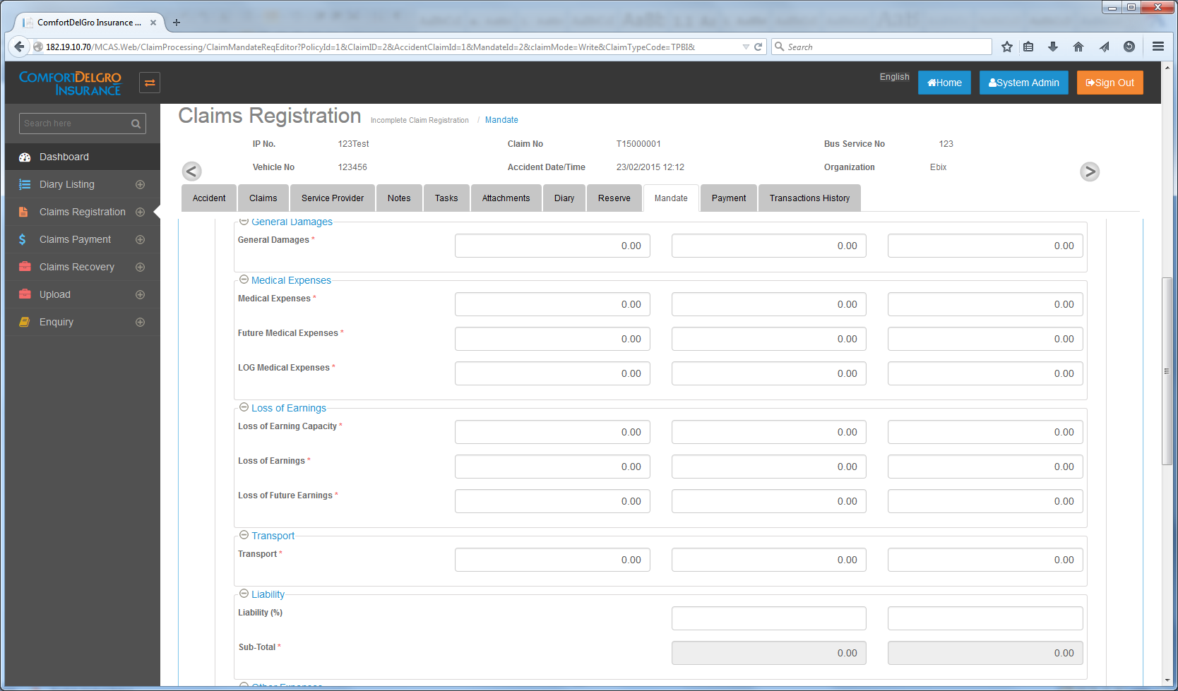

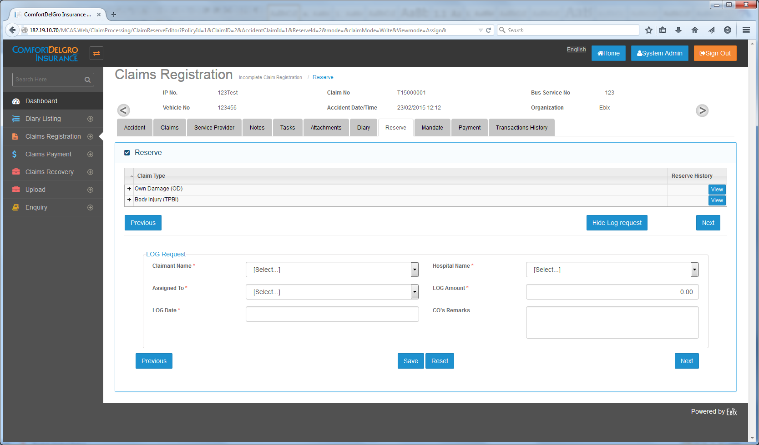

LOG Request Data Fields

* Claimant Name: Auto-populated from BI Claim Registration
* Hospital Name: Select from dropdown. Data pulled from Hospital Master (Mandatory)
* Assigned To: Remove this Field
* LOG Amount: Auto-populated from Approved Mandate Request (Mandatory and non-editable) Note that this LOG Amount must be the amount that Supervisor has approved under LOG Medical Expenses Field in the Mandate Screen.
* LOG Date: User-entry (Mandatory)
* CO’s Remarks: User-entry (Non-mandatory)

# Requirements:

1. Only when TPBI Claims is created and when there is Approved Mandate Amount for LOG Medical Expenses Field, then that Claim Number will flow to the LOG Request Screen for user to click on Create Link to create LOG Request.
2. Approved Mandate Amount for LOG Medical Expenses Field will populate the LOG Amount in the LOG Request Screen and will not be editable.
3. Claimant Name will populate the Name created with the TPBI Claim and not editable.
4. Once User clicks on Save, LOG Reference Number will be generated and the Search Display Results will populate the LOG Reference Number and the Hospital Name.
5. There will be a Print Button beside the SAVE Button. Clicking on the Print Button will bring up a Pop Up to show the two LOG Documents. Selecting one of the documents will populate the Document and allow Users to print out. Document Printed will flow to the Claim Documents Printed Section.
6. Clicking on the Editing Button allows user to change the Hospital Name. This change of Hospital Change is to be captured in the Audit LOG so that the Super Admin can view the list of changes.
7. Clicking on the VOID Button will prevent any more editing to this LOG Request and introduce a LOG Movement to balance out the Mandate. Upon Saving the LOG Request, there is no impact on the Approved Mandate Amount. Upon Voiding the LOG Request, the Approved Mandate Amount is zero-rised. After Void, record becomes read-only.
8. That initial approved Mandate amount will no longer be allowed to use for creating any more LOG Request so user has to go and create a new Mandate Request for LOG Medical Expenses and has it approved first before user can request for New LOG.

# Sample Scenario:

1. Claim Officer requests for $5,000 in the LOG Medical Expenses in the Mandate Screen to be approved by Supervisor.
2. Supervisor sees this request and decides that $5,000 Mandate can be approved.
3. Upon selecting Approved, System will check the final value (i.e. $5,000) in the LOG Medical Expenses Field and populate the LOG Amount with that amount.
4. User can proceed to make a LOG Request with that amount of $5,000
5. If User makes a mistake, user can click on the VOID Link to reject the case and System will introduce a Mandate Movement (indicated by LOG-M) of +$5,000 to neutralize the initial Mandate Movement (related to LOG Medical Expenses) to zero.
6. Once LOG Request has been voided, that LOG Reference will be in view-only mode and no further editing is allowed.
7. To request for a new LOG, User has to go through the process of requesting for a New Mandate and have the amount approved by Supervisor.